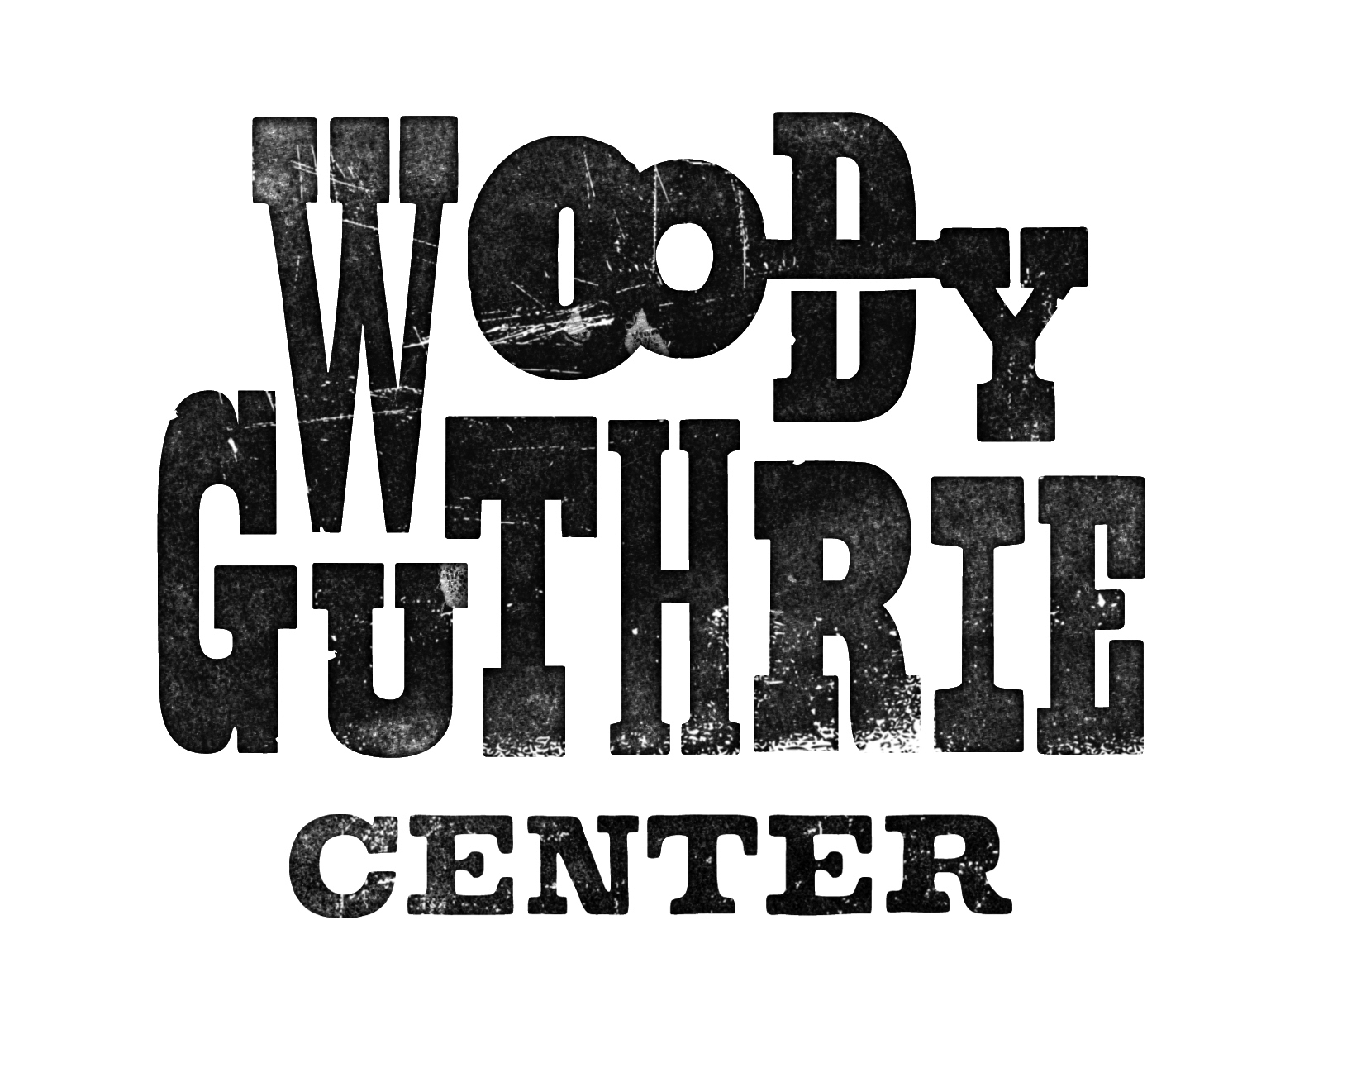
What Was the Dust Bowl?
Rationale
This 50 minute lesson can be used to introduce students to the Dust Bowl.

Guiding Questions
What was the Dust Bowl?
How did it affect Oklahomans?

Mastery Objectives
Students will be able to define “The Dust Bowl”.
Students will analyze the effects of The Dust Bowl on Oklahomans.

Vocabulary
- environment
- refugee
- drought
- migration
- surplus
- scarce

Materials
Computer with internet access
Projector for displaying images
Whiteboard
Attached reading of The Dust Bowl for each student
Attached lyrics of Dust Storm Disaster for each student
Dorothea Lange images available online
Audio of Dust Storm Disaster available online

Procedures
Introduction:
- Ask students what they think the Dust Bowl is.
- Show selected Dorothea Lange images using projector. Ask students what they notice about the images.
- Elicit student responses and predictions for what the Dust Bowl was. Record answers on whiteboard.

Guided Instruction:
- Distribute copies of The Dust Bowl attached reading, and read together.

- Discuss the effects of being forced to abandon your home. What would you take with you? Where would you go?
- Revisit the responses on the board. How close were the predictions? Add to or clarify responses.
- Give students a few minutes to answer the questions with the reading before selecting students to answer orally.
- Explain that Woody Guthrie wrote a ballad about the Dust Bowl. Explain what a ballad is.
- Distribute lyrics to “Dust Storm Disaster” and play song audio. Have students follow along while listening.
- Discuss the song with students. What was the worst storm that they can remember? What were some of its effects? What does your family do when a storm is coming?

Individual Practice:
- Ask students to write their own ballad.
- Have them share their ballads with the class.

Optional Lesson Extensions:
Geography: Once students have labeled the states affected by the Dust Bowl, instruct them to identify areas mentioned in the song Dust Storm Disaster.

Math: Once areas are labeled on map, have students draw a line connecting Albuquerque, Denver, and Oklahoma City, or any three sites. What shape do they form? Calculate area of the shape.

Language Arts: Have students write a conversation between a Dust Bowl refugee arriving in California and a California resident.

**Woody Guthrie Publications owns the copyright for images
The Dust Bowl

For nearly a decade the dust blew across the Southern Plains. Women hung wet sheets over doorways and windows in an effort to stop dust from invading their homes. Children wore dust masks on their way to school and back. Farmers helplessly watched as their crops blew away. This period in history is known as the Dust Bowl, and it is one of the worst environmental disasters the world has ever seen.

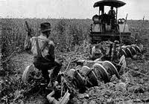
Both man and Mother Nature are responsible for this disaster. During the previous decade, farmers began using new farming equipment. These machines allowed them to farm more land than ever before. By doing this, the native drought-resistant grasses were replaced with wheat. The surplus of wheat caused the prices to drop. Many fields were left bare.

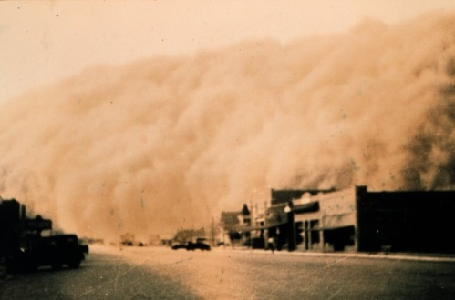
The area affected by the Dust Bowl had little rain fall, light soil, and high winds. When what little rain the area did receive stopped falling, the soil dried very quickly. With no grass to hold the dirt in place, the winds easily picked up the dirt and swirled into dust clouds. The dust clouds, known as “black blizzards,” carried dirt everywhere, and it was impossible to escape it. Dust covered everything.

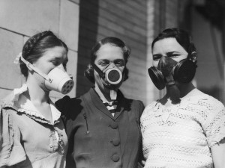
People had dirt in their clothes, hair, and teeth. It even covered the food they ate. Over time, the dust that they breathed and ate built up in their lungs. This lead to a disease called pneumonia. The body was often sent into coughing fits in an effort to rid itself of the dust. Dust pneumonia killed thousands of people. Babies, children, and the elderly were most likely to die from this.

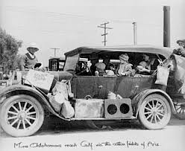
Due to the conditions in Oklahoma, many people left the state. Some chose to leave; others were forced out when banks took their homes and lands. This was the greatest migration in American history. Of the 2.5 million people that left the plains, 200,000 headed for California. These “Okies” as they were called were not met with a warm welcome. Many Californians were angry about the competition for the jobs, which were already scarce. Farms there were much different than the ones in Oklahoma; they used more machines and needed fewer people to provide labor. Some farmers took advantage of the Okies. With so many people hungry and looking for work, there were able to pay very low wages.

Many of the migrants gave up farming when they reached California. They established homes near larger cities. These cities were called Little Oklahomans or Okievilles. These homes were built from scraps and had no electricity or plumbing. Outbreaks or diseases such as malaria, typhoid, smallpox, and tuberculosis were caused by polluted water.

- What were two causes of the Dust Bowl?
_________________________________________________________________________
- What were the refugees called when they reached California?

________________________________________________________________________________

- About how many people left their homes?

_______________________________________________________________________________

- What is the main idea of the passage?

______________________________________________________________________________

- Which sentences support the main idea?

______________________________________________________________________________

Dust Storm Disaster
(Also known as The Great Dust Storm)
Words and Music by Woody Guthrie
On the 14th day of April of 1935,
There struck the worst of dust storms that ever filled the sky.
You could see that dust storm comin', the cloud looked deathlike black,
And through our mighty nation, it left a dreadful track.
From Oklahoma City to the Arizona line,
Dakota and Nebraska to the lazy Rio Grande,
It fell across our city like a curtain of black rolled down,
We thought it was our judgement, we thought it was our doom.
The radio reported, we listened with alarm,
The wild and windy actions of this great mysterious storm;
From Albuquerque and Clovis, and all New Mexico,
They said it was the blackest that ever they had saw.
From old Dodge City, Kansas, the dust had rung their knell,
And a few more comrades sleeping on top of old Boot Hill.
From Denver, Colorado, they said it blew so strong,
They thought that they could hold out, but they didn't know how long.
Our relatives were huddled into their oil boom shacks,
And the children they was cryin' as it whistled through the cracks.
And the family it was crowded into their little room,
They thought the world had ended, and they thought it was their doom.
The storm took place at sundown, it lasted through the night,
When we looked out next morning, we saw a terrible sight.
We saw outside our window where wheat fields they had grown
Was now a rippling ocean of dust the wind had blown.
It covered up our fences, it covered up our barns,
It covered up our tractors in this wild and dusty storm.
We loaded our jalopies and piled our families in,
We rattled down that highway to never come back again.

The Ballad

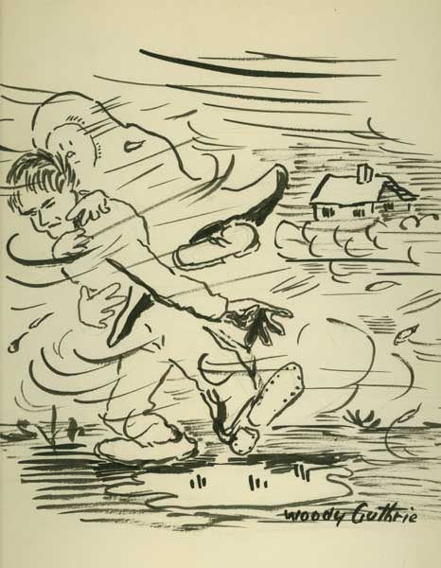
Woody Guthrie 1912-1967 was an American singer-songwriter and folk musician. His legacy includes thousands of songs. He wrote songs for children, adults, and for people he felt were being treated poorly. He used his songs as a way to bring attention to those whom he felt were being neglected.
Sometimes Woody Guthrie used his songs to tell a story; these songs are called ballads. A ballad is story set to music; they focus on action and dialogue. They are simple, easy to understand and usually written on heroic, romantic, or political actions.
The “Dust Storm Disaster” is an example of a ballad.
In the space provided below, write your own ballad of a family affected by the Dust Bowl.

_______________________________________________________________________________
_______________________________________________________________________________
_______________________________________________________________________________
_______________________________________________________________________________
_______________________________________________________________________________
_______________________________________________________________________________
_______________________________________________________________________________
_______________________________________________________________________________
_______________________________________________________________________________
_______________________________________________________________________________

“The Dust Bowl” Vocabulary Practice
Name:__________________________ Date:__________________
Word Bank
Environment Refugee Drought Migration Surplus Scarce

Part I: Completion
Directions: Use the correct term from the word bank to complete each sentence.
- Both food and work were ______________________ for many people.

- Lessons learned from the Dust Bowl taught us to better care for our _________________.

- The lack of food and jobs led to a(n) ____________________ out of the area.

- These ___________________ were not always treated well in their new homes.

- The limited number of jobs created a(n) _________________ of labor.

- New farming techniques and a severe ___________________ created conditions for the Dust Bowl.
Part II: Short answer
Directions: Answer the following questions in complete sentences.

- What are some resources today that are scarce?
_______________________________________________________________________________________

_______________________________________________________________________________________

- What are some items of which you have a surplus?
______________________________________________________________________________________

______________________________________________________________________________________

- What might cause a person today to be a refugee?
______________________________________________________________________________________

______________________________________________________________________________________

- What are some things you do to help protect the environment?
______________________________________________________________________________________

______________________________________________________________________________________

