Reading Visual Images
Rationale
This lesson can be used to introduce students to the idea of visual literacy as well as provide practice.

Guiding Questions
What is visual literacy?
Why is visual literacy important?
Why communicate a message through images?
How can images be a powerful medium to communicate?

Mastery Objectives
Students will be able to read visual media.

Materials
Copies of this packet

Procedures
- Distribute copies of the worksheets to students.
- Briefly discuss when we may encounter visual messages.
- As a class, analyze the first image using the questions provided.
- Have students attempt analyzing the second image on their own.
- Have students choose a topic and convey a message using text and an image they produce.

Woody Guthrie was one of the most creative people the world has ever known. He created something nearly every day in the form of songs, journal writings, or drawings. In his autobiography, Bound for Glory, he describes his obsession with art:

Things was starting to stack up in my head and I just felt like I was going out of my wits if I didn’t find some way of saying what I was thinking. The world didn’t mean more than a smear to me if I couldn’t find ways of putting it down on something. (Guthrie 177)

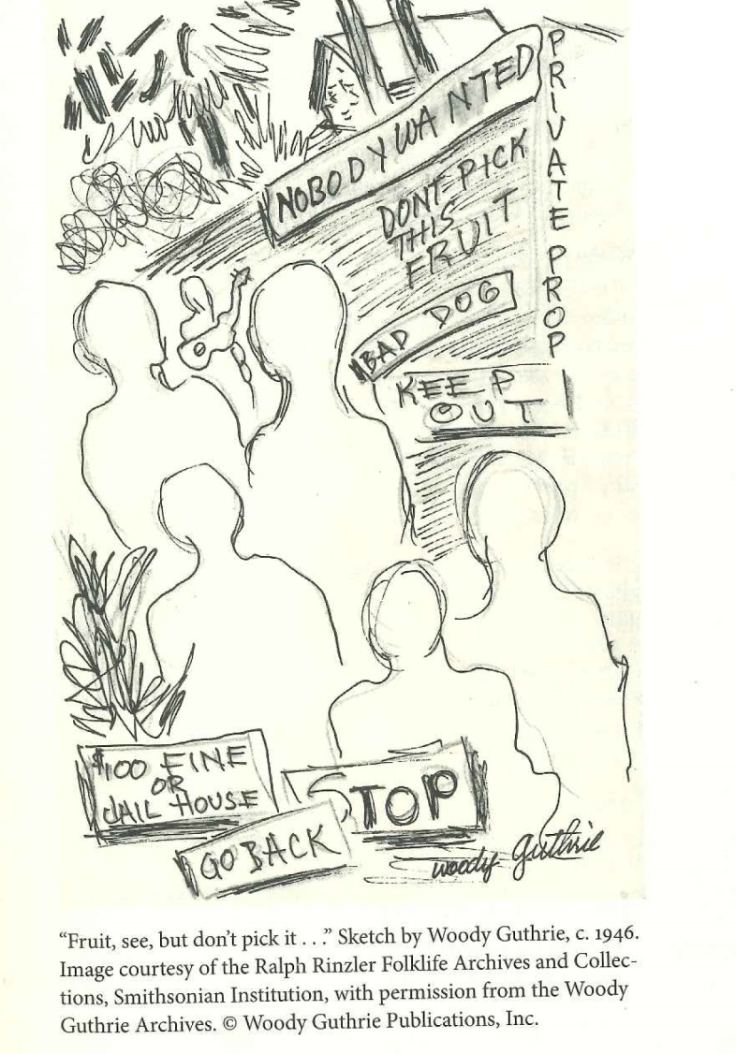
He discovered that through his art he had a voice; he could change things. Initially, the changes he sought were small ones: beautifying towns or houses, or simply cheering someone up. Later, after becoming more active, his artwork sought to bring change or relief for struggling people.
Directions: Use the above illustration to answer the questions below.
Part I: Observation

- Who created this primary source? ____________________________________________

- During what period in history was it created?__________________________________________

- What do you see?_________________ ______________________________________________

- Why might the people be faceless?__________________________________________________

- Who is the audience for this cartoon?_______________________________________________

- Notice any text in the picture. What does it say?______________________________________

- What images are the most powerful?_______________________________________________

Part II: Making Connections

- What event inspired the picture?___________________________________________________

- What is the cartoonist’s point of view of the topic portrayed?____________________________

- What from the cartoon supports your opinion?_______________________________________

Part III: Drawing Inferences

- What might we infer from what we noticed so far?___________________________________

The above picture was drawn to bring attention to the plight of migrant workers during the Dust Bowl. The following report is meant to do the same.

CUTTINGS FROM THE COLLINS REPORT
From Collins’s report of January 18, 1936
This week we learned that the average farm labor wage in the state of Oklahoma is fifty cents during peak harvests, with a wage of thirty cents for off season labor. [Here] boll picking [pays] sixty cents per hundred pounds. Men engaged in this work have earned an average of sixty-five cents per day.
From Collins’s report of February 8, 1936, p. 15
[Note: Mr. Palomaris was a speaker at a Chamber of Commerce meeting to which Collins was invited. Collins hastily took notes during the meeting.]
(Mr.) Palomaris said, “…Government camps are a source of danger. Communistic activities will be common. Famers must awake to the danger before too late. …growers… are busy arranging for …12 big camps …supervised and conducted by the growers themselves under strict supervision. Sheriffs will be able to go to the camps any time.”
From Collins’s report of May 2, 1936
Several families have checked out for other points rather than remain at camp unemployed… Some of them believe it will be necessary to get as far north as Sacramento …to obtain employment for four months.
From Collins’s report of May 23, 1936, p. 5
Tucker …refused to pay [as agreed per row] and the group walked off to accept work on another farm where the scale was $0.25 per hour. 3 of our women were involved in this incident. (Tucker is the proprietor of the notorious slum district of Arvin known as “Tuckertown”.)
From Collins’s report of July 18, 1936, p. 4
He…reminded his hearers that an advertising campaign in the Oklahoma and Arkansas press would bring out, on short notice, hundreds and probably thousands of workers from those states and that those workers would be very willing and quite happy to work for the 25 cents per hour scale now in effect at that corporation ranch. This seems to have broken the threat of an immediate strike for higher wages…

Which form of media is more powerful and why?

Why might someone choose one form over the other?

What limitations does each form have?

Discuss this image using the applicable questions from the previous page. (#s 3,6,7,8,9,11)

Do you agree with this cartoon? Do you see any problems/limitations to this p.o.v?

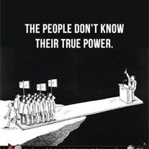

On the back of this page, choose a topic and convey a message using text and an image.

