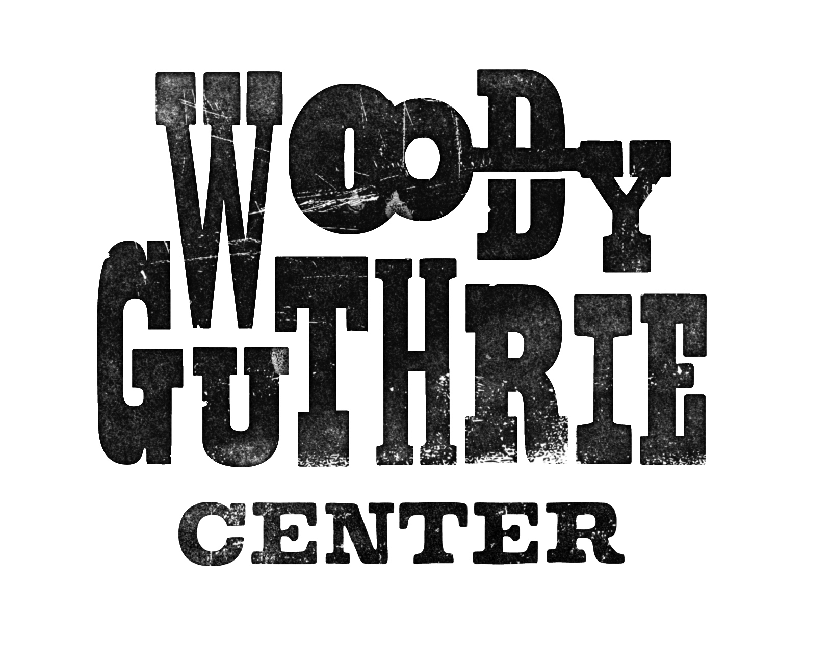***Migrant Farm Workers of the Great Depression***

**Rationale**

This lesson can be used to introduce students to the conditions that migrant farm workers faced during the Dust Bowl.

**Guiding Questions**

What are migrant farm workers?

What conditions gave rise to migrant workers?

How were migrant farm workers treated by land owners?

**Mastery Objectives**

Students will have an understanding of migrant workers, the conditions they faced, and the treatment they received.

**Vocabulary**

Recession

Migrant

Infrastructure

Indigent

Transience

**Materials**

Copies of attached reading for each student

***Woody Guthrie Publications owns the copyright to images and lyrics.

***Plight of Migrant Workers***

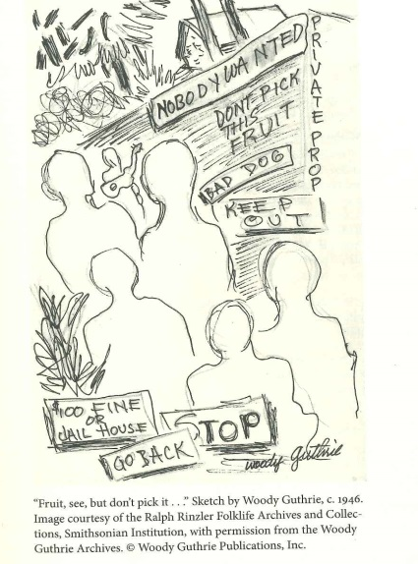

**From Farmer to Migrant**

Following World War I, the United States experienced an economic recession. Falling food prices forced farmers to produce more crops and cultivate more land in an attempt to increase their profits. The debt incurred by purchasing modern equipment caused financial hardships on many farmers. When the stock market crashed in 1929 many of them were forced off their lands; independent farmers were forced off by banks when they couldn’t pay their note, and tenant farmers were kicked off by large land owners. These newly unemployed farmers were forced into an already saturated employment market.

Environmental conditions also played a role in the increase of migrant workers. When a drought began in 1931, the land quickly dried up. Without the native grasses, which were plowed up with the expanding farmland, the soil blew away. These storms of dust, known as black blizzards, and the lack of work drove farmers and unemployed blue-collar workers out of the area.

**The lure of California**

Wanting to escape the harsh climate of the Plains, many of the “Dust Bowl refugees” made their way to California. The stable climate and range of crops brought the promise of work. Once they arrived however, reality of life in California set in; it was not the Promised Land they had expected. California, too, suffered under the conditions that had become The Great Depression.

**The “Bum Blockade”**

With many Californians unemployed and migrants arriving daily, the state and local government infrastructures were overwhelmed. Until a 1941 ruling by the U.S. Supreme Court, states were free to restrict interstate mobility, and no state was more hostile to migrants than California. A border patrol nicknamed the “Bum Blockade” was established by the Los Angeles police. They were stationed at major road and rail crossings and turned back those who appeared to lack means to support themselves. The State even went as far as to pass California’s Indigent Act which made it illegal to bring indigents into the state.

**Paradise Lost**

Even for those who made it into California, the struggle certainly wasn’t over. Their life of transience was to continue. In order to keep a steady income, they had to follow the harvest around the state. Besides the impact that type of grueling lifestyle had on the workers themselves, their families also suffered. Children were often unable to attend or finish school, leaving them with little choice but to continue the migrant farmworker lifestyle.

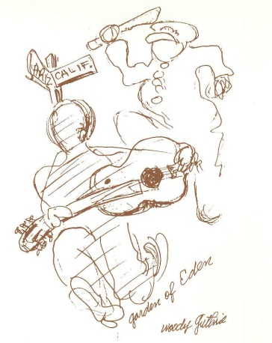

**Exploitation of Labor**

Workers found that the available workforce far exceeded the number of jobs available. These conditions led to a significant reduction in pay. Often, even with an entire family working, they still could not support themselves. They spent their days harvesting crops that they themselves were not allowed to eat even though they were starving. Unable to afford even basic housing, some workers set up camps in farmer’s fields, while others built makeshift homes out of scraps. Lack of running water and overall unsanitary conditions often contributed to the spread of disease and illness in these areas. While laws and labor unions protected workers in cities and towns, famers had long been exempt from these standards.

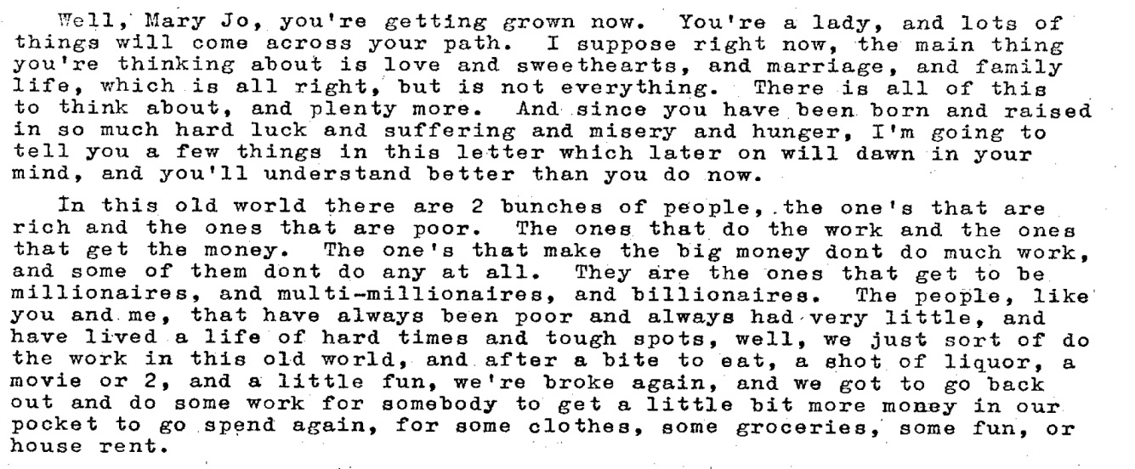

*Excerpt of letter from Woody Guthrie to Mary Jo Guthrie*

**Impact on Minorities**

Minorities were hit especially hard during these times. Many lost their jobs to Whites that had been displaced by the Great Depression. The plight of minorities was often ignored because journalists knew that refugees with white skin and Anglo-Saxon names would garner more sympathy and attention from the public. Because of this, poverty became more and more racialized and contentious.

(adapted from “The Dust Bowl Migration” Poverty in the United States: An Encyclopedia of History, Politics, and Policy, eds. Gwendolyn Mink and Alice O’Connor and “Voices from the Dust Bowl: The Migrant Experience” Library of Congress.

Name:____________________________ Date:_________________________

Reading Questions

1. Is Man or Nature more to blame for the Dust Bowl? Why?
2. Why were Californians not welcoming to migrants?
3. Why is it ironic that the refugees spent their days harvesting crops?
4. Why would the government not want indigents, in particular, migrating to the state?
5. What other effects might a transient lifestyle have on families?
6. How might harvesting crops in California be different from harvesting crops Oklahoma?
7. Explain the impact felt on minorities during the Dust Bowl.
8. How might this have affected race relations during the time?

If you were a large farm owner or government official in California during the Dust Bowl, how would you have treated the migrants? Explain.

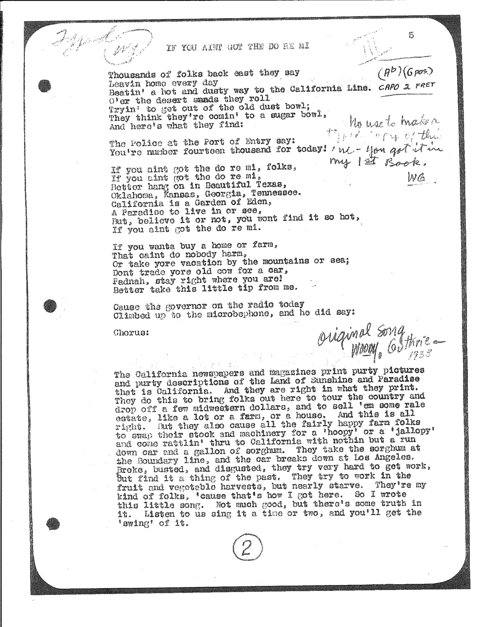

Name:__________________________ Date:_____________________

***Do Re Mi***

As you see from the previous page, Guthrie wrote *Do Re Mi* as a warning to people who were considering heading west to escape the Dust Bowl and its effects. Refer to the lyrics and his commentary on the page when answering the following questions.

1. What is the tone of the song?________________________________________________________
2. What word(s) contribute to the tone?__________________________________________________
3. What message is Guthrie sending to people back west?____________________________________
4. How do California newspapers and magazines tempt people to come to California?____________________
5. Why do they tempt people to come to California?_______________________________________________
6. How does Guthrie feel about these actions?____________________________________________________
7. What stands out to you about Guthrie’s language?______________________________________________
8. What effect does this language have on his audience?____________________________________________

Name:___________________________ Date:_______________________

Vocabulary

Directions: Complete the sentences and analogies below with the appropriate vocabulary word.

1. The effects of the _______________________ were felt by everyone in the country.
2. During the Dust Bowl, many farmers became _____________________ and were unable to take care of their families.
3. The _____________________ of California was overwhelmed by the number of migrants arriving.
4. The migrants lived a life of _______________________ making it difficult to raise a family.
5. Harvesting the crops as a ______________________ worker meant moving frequently.

Word Bank:

recession migrant infrastructure

indigent transience

Directions: Analogies are pairs of words that show relationship. Complete each analogy below with a vocabulary word. An example has been done for you.

Example: breeze : gale :: trickle : cascade

1. _____________ : permanent :: light : dark
2. ____________ : nomad :: examine : peruse
3. Prevent : stop :: _____________ : decline
4. Petal : flower :: bridge : ________________
5. Constrain : release :: indigent ::______________