This Land is Your Land

Rationale
This lesson can be used to teach elementary students the meaning behind the song
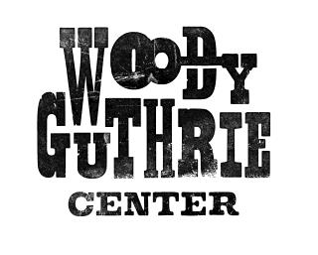This Land is Your Land.

Guiding Questions
What led to the writing of This Land Is Your Land?

Mastery Objectives
Students will be able to tell who Woody Guthrie was.
Students will be able to talk about the song This Land is Your Land.

Vocabulary Protest Theme
Main idea
Conflict

Materials
A copy of this reading for each student
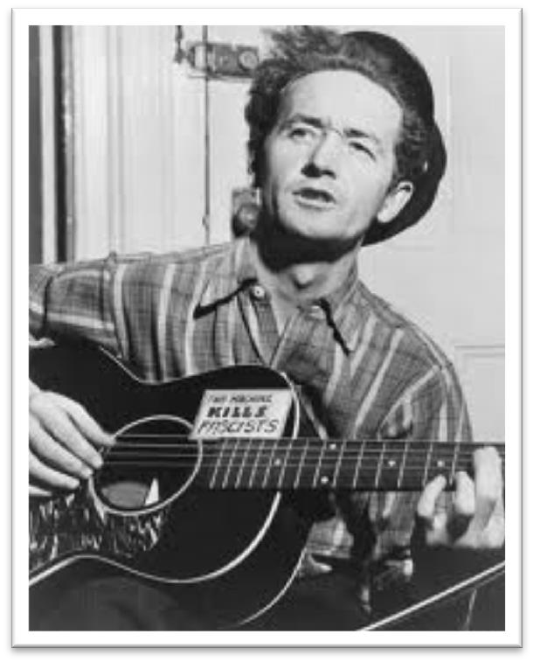Woody Guthrie was born in Okemah, Oklahoma in 1912. His childhood was pretty ordinary. He spent his time playing outside, carving his name in trees, and putting on performances on his porch.

One of his favorite activities was listening to music. His mother would sing church hymns and old folk songs to him.
He was fascinated by the idea of delivering a message through song and began writing poems. This passion would stay with him throughout his entire life, and it would be the way he left his mark on the world.

One of his most well-known songs is This Land is Your Land. He wrote the song in 1940, but it stayed hidden in his notebook until 1944.

The song was later printed in school books and sung by children in school which helped it become very popular.

The song tells about the promise of America. It creates an image of a country with endless opportunities and beautiful sights and sounds.

Directions:

1. On the attached map, label each area Guthrie talks about in the song.
2. What are the rhyming words?
3. What do you think Guthrie’s opinion of the U.S. is?
4. What words or phrases from the song make you think that?
5. What is the main idea in this song?
6. What phrase is the most important support of his idea?
This Land Is Your Land
Words and Music by Woody Guthrie

Chorus:

This land is your land, this land is my land
From California to the New York island;
From the red wood forest to the Gulf Stream waters
This land was made for you and me.

As I was walking that ribbon of highway, I saw above me that endless skyway:
I saw below me that golden valley: This land was made for you and me.

Chorus

I've roamed and rambled and I followed my footsteps To the sparkling sands of her diamond deserts; And all around me a voice was sounding:
This land was made for you and me.

Chorus

When the sun came shining, and I was strolling,
And the wheat fields waving and the dust clouds rolling, As the fog was lifting a voice was chanting:
This land was made for you and me.

Chorus
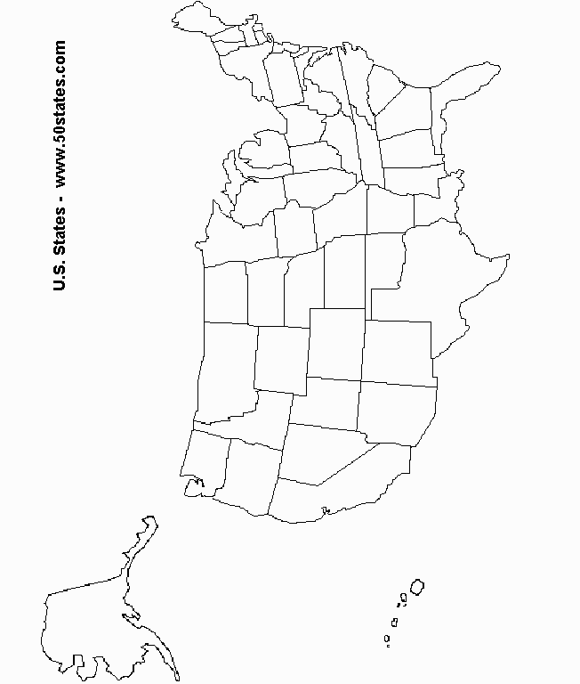
That is all most people know about the song. But really, This Land is Your Land is a protest song, and there are additional verses that most people don’t know. A protest song is one that is written to bring attention to or change an issue. The first three verses and chorus describe a beautiful country with natural riches and beauty. Starting with verse four,
Guthrie began to criticize the greed in America. The country he describes in this part of the song is certainly not perfect.

As I went walking I saw a sign there And on the sign it said "No Trespassing." But on the other side it didn't say nothing, That side was made for you and me.

In the shadow of the steeple I saw my people, By the relief office I seen my people;
As they stood there hungry, I stood there asking
Is this land made for you and me?

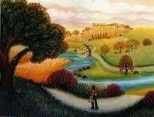Nobody living can ever stop me,
As I go walking that freedom highway; Nobody living can ever make me turn back This land was made for you and me.

.

1. What images in America does Guthrie describe here?
2. What problems does he see in America?
3. What is the main idea of this portion of the song?

