Don’t Kill My Baby and My Son

Rationale
This lesson can be used to introduce students to a famous song by Woody Guthrie and the story behind it, as well as introduce students to the idea of Guthrie as a proponent of civil
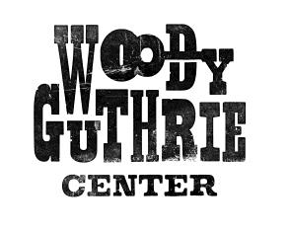rights.

Materials
A copy of the attached reading for each student
Hear Joel Rafael’s version of “Don’t Kill my Baby and My Son” here: https://www.youtube.com/watch?v=LyMC6E-6YlI

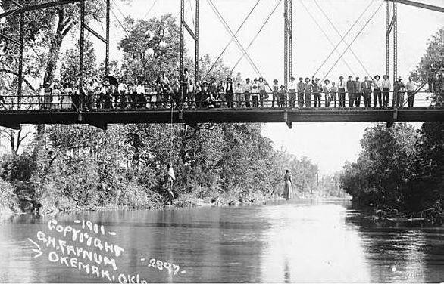Lynching of Laura Nelson
Photograph by: George Henry Farnum
Wikipedia.com
August 12, 2013

Don’t Kill My Baby and My Son
Words and Music by Woody Guthrie

As I walked down that old dark town
In the town where I was born,
I heard the saddest lonesome moan
I ever heard before.

My hair it trembled at the roots Cold chills run down my spine, As I drew near that jail house
I heard this deathly cry:

O, don't kill my baby and my son, O , don't kill my baby and my son.
You can stretch my neck on that old river bridge, But don't kill my baby and my son.

Now, I've heard the cries of a panther, Now, I've heard the coyotes yell,
But that long, lonesome cry shook the whole wide world
And it come from the cell of the jail.

Yes, I’ve heard the screech owls screeching, And the hoot owls that hoot in the night, But the graveyard itself is happy compared To the voice in that jailhouse that night.

Then I saw a picture on a postcard
It showed the Canadian River Bridge,
Three bodies hanging to swing in the wind, A mother and two sons they'd lynched.

There's a wild wind blows down the river, There's a wild wind blows through the trees,
There's a wild wind that blows 'round this wide wide world, And here's what the wild winds say:
1. In what ways might the town be “dark”?

2. What things are being personified in the second stanza?

3. Note the actions the objects being personified perform. What mood is created?

4. In the fourth stanza, Guthrie compares the cries of the mother to those of animals. What might the mother and those animals have in common?

5. Who does the speaker want to be saved?

6. What is the tone of this song?

7. What words contribute to the tone?
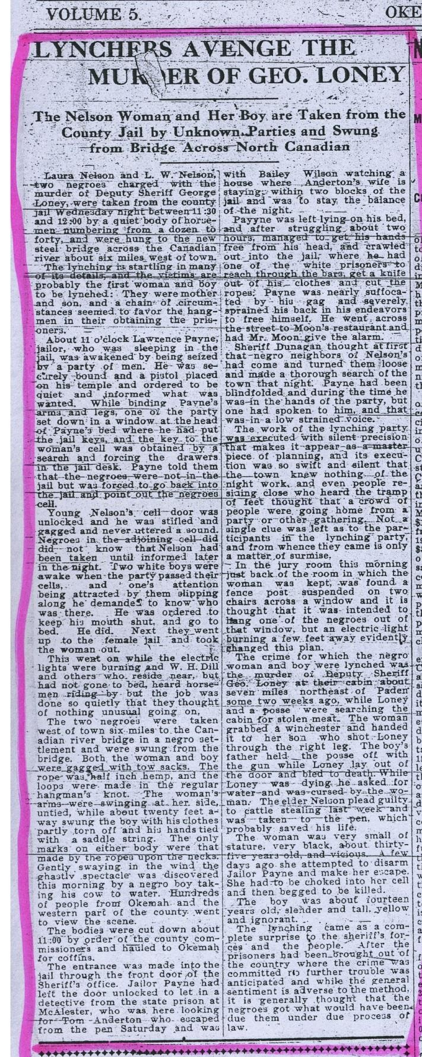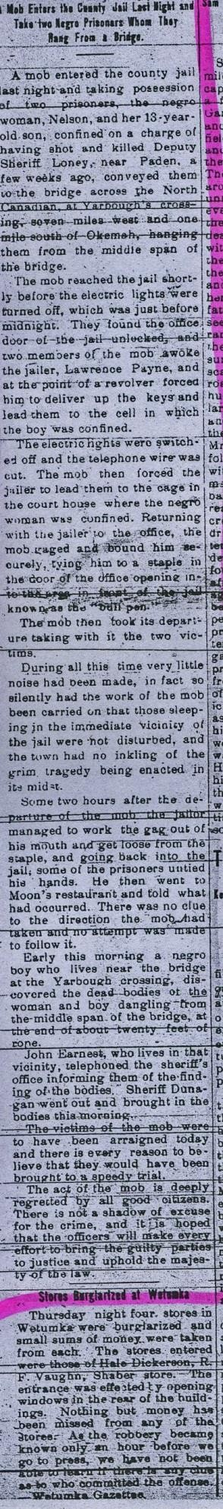Read the following newspaper articles written about the abduction and lynching of the Nelsons. Discuss how the articles and the song are different in focus, tone, etc.

The Independent May 25, 1911 Okemah Ledger May 25, 1911

