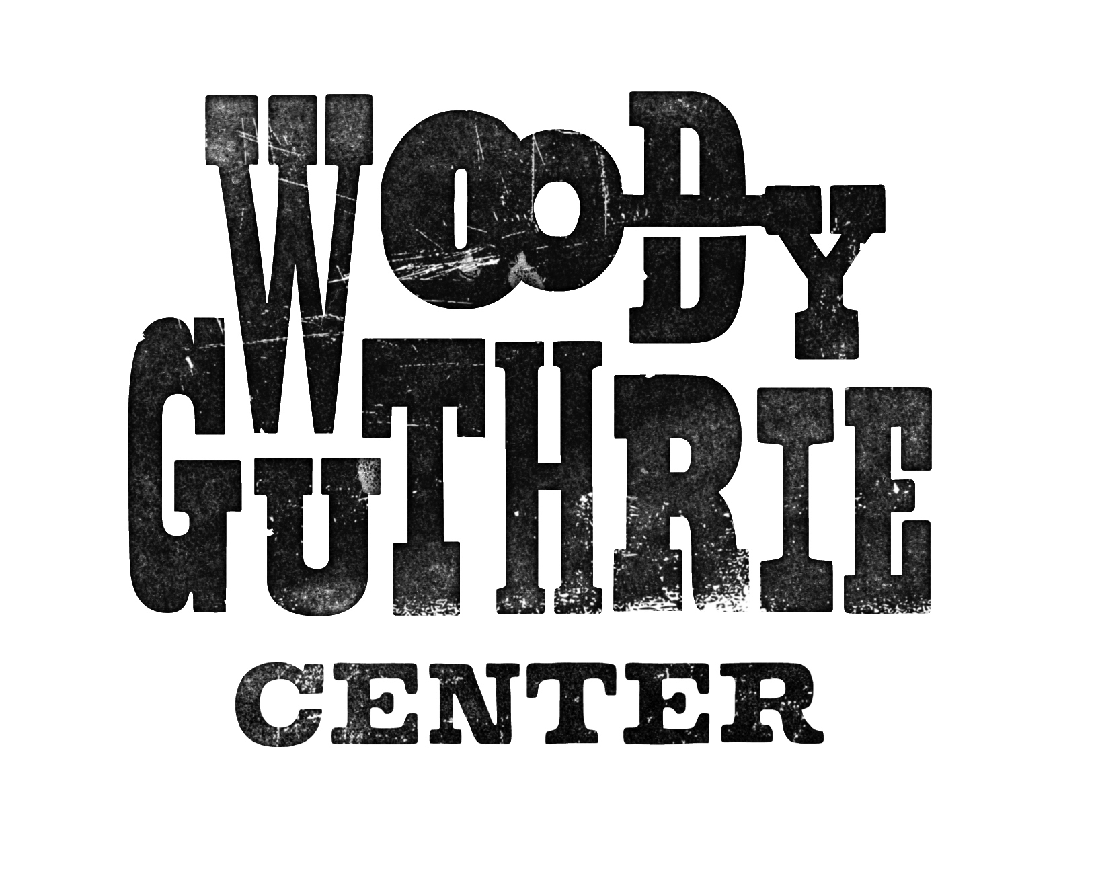
The Ballad of Tom Joad
Rationale
This lesson can be used to introduce students to the elements of fiction using a ballad.

Guiding Questions
What makes a work of fiction?

Mastery Objectives
Students will be able to define and identify the elements of fiction in a work.

Vocabulary
Plot
Character
Setting
Theme
Conflict
Point of View

Materials
Copy of attached reading for each student
Computer with internet connection & speakers (optional)
Projector (optional)

Procedure
- Begin by asking students to think of their favorite movies, television shows, or stories.
- Once they have named a few, choose one that is well-known to discuss as a class.
- Ask students to recall the events that took place, characters, problems, etc. and explain that those are the elements of fiction. Label each vocabulary word according to the story the class discussed.
- Distribute the attached paper, “Elements of Fiction.”
- On a sheet of paper, have students write down each of the vocabulary words.
- Tell them you will read them a well-known story and they are to identify the elements as they learn them.

Read The Story of the Three Little Pigs. A copy with illustrations can be found here: http://www.read.gov/books/three-pigs.html

Once students feel comfortable identifying these elements, distribute copies of “Tom Joad.”

Students can listen to the song on youtube: http://www.youtube.com/watch?v=WKWGAGPy_kw

Ask students to identify the elements of fiction either individually or in pairs.

Review and discuss answers with students.

Give students copies of “Dust Storm Disaster” and ask students to identify the elements on their own.

Now that students are familiar with the elements of fiction, you can introduce them to types of characterization.

Ask students to once again imagine their favorite character from books, TV shows or movies.

Have them brainstorm words to describe the character; then ask them to tell what makes them think those things about the character.

Explain that authors can reveal the personality of a character in two ways – directly or indirectly. When a reader or view has to make inferences about a character, the author is using indirect characterization.

Return to The Story of the Three Little Pigs. Ask students to describe the character of the wolf using examples from the story. Help them determine if the author used direct or indirect characterization.

Have students return to “Tom Joad” and discuss the characterization of the characters.

Elements of Fiction

Plot – the events that makeup a story

Character – a person in the city

Setting – where a story takes place

Theme – the subject of a literary work

Conflict – the problem in a story

Point of View – the perspective from which a story is told. The most common points of view in literature are first-person, third-person limited, and third-person omniscient. In first-person, the narrator is a character in the story and reveals the plot using first-person pronouns such as “I” or “we”. In third-person, the narrator refers to characters using third-person pronouns such as “he”, “she”, “it”, or “they”. A limited narrator knows all the thoughts and actions of one character, while an omniscient narrator knows the thoughts and actions of all the characters.

Direct characterization – when an author makes statements about a character directly to the reader

Indirect characterization – when the reader learns about a character through his/her thoughts, actions, appearance, etc.

Tom Joad
Words and Music by Woody Guthrie
Tom Joad got out of the old McAlester Pen;
There he got his parole.
After four long years on a man killing charge,
Tom Joad come a-walkin' down the road, poor boy,
Tom Joad come a-walkin' down the road.
Tom Joad, he met a truck driving man;
There he caught him a ride.
He said, "I just got loose from McAlester Pen
On a charge called homicide,
A charge called homicide."
That truck rolled away in a cloud of dust;
Tommy turned his face toward home.
He met Preacher Casey, and they had a little drink,
But they found that his family they was gone,
He found that his family they was gone.
He found his mother's old-fashion shoe,
Found his daddy's hat.
And he found little Muley and Muley said,
"They've been tractored out by the cats,
They've been tractored out by the cats."
Tom Joad walked down to the neighbor's farm,
Found his family.
They took Preacher Casey and loaded in a car,
And his mother said, "We've got to get away."
His mother said, "We've got to get away."
Now, the twelve of the Joads made a mighty heavy load;
But Grandpa Joad did cry.
He picked up a handful of land in his hand,
Said: "I'm stayin' with the farm till I die.
Yes, I'm stayin' with the farm till I die."
They fed him short ribs and coffee and soothing syrup;
And Grandpa Joad did die.
They buried Grandpa Joad by the side of the road,
Grandma on the California side,
They buried Grandma on the California side.
They stood on a mountain and they looked to the west,
And it looked like the promised land.
That bright green valley with a river running through,
There was work for every single hand, they thought,
There was work for every single hand.
The Joads rolled away to the jungle camp,
There they cooked a stew.
And the hungry little kids of the jungle camp
Said: "We'd like to have some, too."
Said: "We'd like to have some, too."
Now a deputy sheriff fired loose at a man,
Shot a woman in the back.
Before he could take his aim again,
Preacher Casey dropped him in his track, poor boy,
Preacher Casey dropped him in his track.
They handcuffed Casey and they took him in jail;
And then he got away.
And he met Tom Joad on the old river bridge,
And these few words he did say, poor boy,
These few words he did say.
"I preached for the Lord a mighty long time,
Preached about the rich and the poor.
Us workin' folkses, all get together,
'Cause we ain't got a chance anymore.
We ain't got a chance anymore."
Now, the deputies come, and Tom and Casey run
To the bridge where the water run down.
But the vigilante thugs hit Casey with a club,
They laid Preacher Casey on the ground, poor Casey,
They laid Preacher Casey on the ground.
Tom Joad, he grabbed that deputy's club,
Hit him over the head.
Tom Joad took flight in the dark rainy night,
And a deputy and a preacher lying dead, two men,
A deputy and a preacher lying dead.
Tom run back where his mother was asleep;
He woke her up out of bed.
An' he kissed goodbye to the mother that he loved,
Said what Preacher Casey said, Tom Joad,
He said what Preacher Casey said.
"Ever'body might be just one big soul,
Well it looks that a-way to me.
Everywhere that you look, in the day or night,
That's where I'm a-gonna be, Ma,
That's where I'm a-gonna be.
Wherever little children are hungry and cry,
Wherever people ain't free.
Wherever men are fightin' for their rights,
That's where I'm a-gonna be, Ma.
That's where I'm a-gonna be."
Dust Storm Disaster
(aka. The Great Dust Storm)
Words and Music by Woody Guthrie
On the 14th day of April of 1935,
There struck the worst of dust storms that ever filled the sky.
You could see that dust storm comin', the cloud looked deathlike black,
And through our mighty nation, it left a dreadful track.
From Oklahoma City to the Arizona line,
Dakota and Nebraska to the lazy Rio Grande,
It fell across our city like a curtain of black rolled down,
We thought it was our judgement, we thought it was our doom.
The radio reported, we listened with alarm,
The wild and windy actions of this great mysterious storm;
From Albuquerque and Clovis, and all New Mexico,
They said it was the blackest that ever they had saw.
From old Dodge City, Kansas, the dust had rung their knell,
And a few more comrades sleeping on top of old Boot Hill.
From Denver, Colorado, they said it blew so strong,
They thought that they could hold out, but they didn't know how long.
Our relatives were huddled into their oil boom shacks,
And the children they was cryin' as it whistled through the cracks.
And the family it was crowded into their little room,
They thought the world had ended, and they thought it was their doom.
The storm took place at sundown, it lasted through the night,
When we looked out next morning, we saw a terrible sight.
We saw outside our window where wheat fields they had grown
Was now a rippling ocean of dust the wind had blown.
It covered up our fences, it covered up our barns,
It covered up our tractors in this wild and dusty storm.
We loaded our jalopies and piled our families in,
We rattled down that highway to never come back again.

